Resource Manager Documentation

The source code for this program is uploaded in my portfolio, the executable program is uploaded to my github repository: <https://github.com/BigMX/GuildHall-Resource-Manager> because this program is created with Qt widget and requires many dependency file for GUI display.

Intent

This program is a basic Resource Manager for a Real Time Strategy (RTS) game. The intent of this program is to manage the resources and manage chain reactions among different nodes.

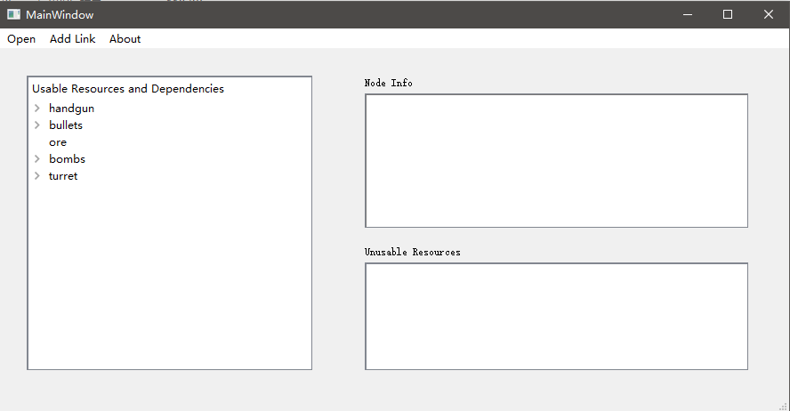

Scope

This application is written in C++ and the GUI is made with Qt Widget tools. In this program. User can load resources file in and delete resources in the node info field. When one resource is deleted, its parents node and all nodes that depend on this node will be moved to unusable resources. In the program, user can also add links between two nodes and put them in usable resources.

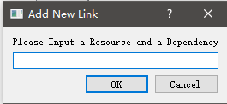

A user instruction video is uploaded along with the source code.